3D Mesh Normalization, Quantization, and Reconstruction
Github repository: https://github.com/RuchitShivani/3D-Mesh-Normalization-Quantization-and-Reconstruction/blob/main/README.md
Submitted by: Ruchit Shivani
Mesh Statistics:
Number of Vertices: 2767
Number of Faces: 1960
Minimum Coordinates: [-0.851562, 0.000000, -0.464844]
Maximum Coordinates: [0.849609, 1.900391, 0.462891]
Mean Coordinates: [0.075443, 1.087390, 0.121967]
Standard Deviation: [0.343380, 0.456991, 0.200067]
Best Normalization Method: Unit Sphere
Average MSE per Axis: [0.0000124, 0.0000189, 0.0000107]
Overall Reconstruction Error (MAE): 0.00382
Relevant Visualization: [Open3D Render Snapshot — Unit Sphere Normalization]

Before we dive into the logic and technical steps used in this process, there are a few relevant concepts that helped in understanding the workflow of this project. Here are their simplified definitions:

1. 3D Mesh
A mesh is a 3D object composed of vertices (points) and faces (triangles) that define its surface. The vertices contain the x, y, and z coordinates that determine its structure in 3D space.
2. Vertex Normalization
Normalization brings vertex coordinates into a common numerical scale, enabling consistent comparison and quantization.
Two main normalization methods were used:
- Min–Max Normalization: Scales each axis independently to [0, 1].
- Unit Sphere Normalization: Centers the mesh at the origin and scales it to fit inside a sphere of radius 1.

3. Quantization
Quantization converts continuous normalized coordinates into discrete bins (integers).
Here, a bin size of 1024 was used, meaning each axis was divided into 1024 discrete levels.
This step reduces data precision while allowing efficient storage and processing.

4. Dequantization and Denormalization
Dequantization converts the integer values back into normalized floating-point values,
and denormalization restores them to the original scale using stored parameters
(either min/max values or centroid and radius).

5. Reconstruction Error
To evaluate accuracy, two key metrics were used:
- Mean Squared Error (MSE): Measures the average squared difference between original and reconstructed vertices.
- Mean Absolute Error (MAE): Measures the average absolute deviation between original and reconstructed values.
A smaller MSE/MAE value indicates a more faithful reconstruction of the mesh.
6. Error Visualization
To visualize reconstruction fidelity, absolute errors were plotted per axis (x, y, z).
Smooth, low-amplitude plots indicate better preservation of the original mesh geometry after quantization.
7. Objective
The objective of this project was to determine which normalization method—Min–Max or Unit Sphere—preserves the mesh structure best after quantization, dequantization, and reconstruction.
Explanation
Each .obj mesh was first loaded and inspected using the Trimesh library to extract vertex data and compute basic geometric statistics (min, max, mean, std per axis).
Two normalization methods were then applied:
- Min–Max Normalization: Each axis was scaled independently to [0, 1], preserving per-axis proportions but possibly distorting the global shape when the mesh was non-cubic.
- Unit Sphere Normalization: Vertices were centered at the mesh’s centroid and scaled uniformly by the maximum distance from the center, maintaining consistent scaling across all dimensions.
After normalization, vertices were quantized into 1024 discrete bins using rounding operations.
Quantized meshes were exported and visualized to ensure the geometry remained intact.
To reconstruct the mesh, the process was reversed:
- Dequantization was applied to restore normalized floating-point coordinates.
- Denormalization re-scaled vertices back to their original units.
The reconstructed mesh was then compared with the original using MSE and MAE per axis and overall.
Error plots were generated for each axis (x, y, z) to visually observe the deviation patterns.

Methodology
- Importing Libraries: The Python libraries used were:
  - Trimesh for mesh loading and export
  - Open3D for visualization
  - NumPy for matrix and vector operations
  - Matplotlib for plotting reconstruction errors
- Loading the Mesh: .obj meshes were imported into Colab using trimesh.load().
Each mesh contained vertex and face arrays defining its geometry.
- Computing Basic Statistics: For every mesh, the number of vertices and faces were printed along with min, max, mean, and standard deviation per axis.
- Normalization: Two independent methods were applied:
  - Min–Max Normalization: ( (v - v_{min}) / (v_{max} - v_{min}) )
  - Unit Sphere Normalization: ( (v - c) / r ) where c = centroid, r = max distance from centroid.
- Quantization:
Normalized vertices were mapped to integers: ( q = round(v_{norm} \times (bins - 1)) ) where bins = 1024.
- Dequantization & Denormalization: The process was reversed to recover approximate original coordinates.
- Error Computation: MSE and MAE were computed per axis and overall to quantify the reconstruction quality.
- Visualization: Error graphs were plotted, and reconstructed meshes were visualized in 3D using Open3D. The lower the error amplitude, the better the quantization fidelity.
- Result Evaluation: The normalization method producing lower reconstruction errors and smoother error plots was identified as the optimal one.

Relevant Outputs:
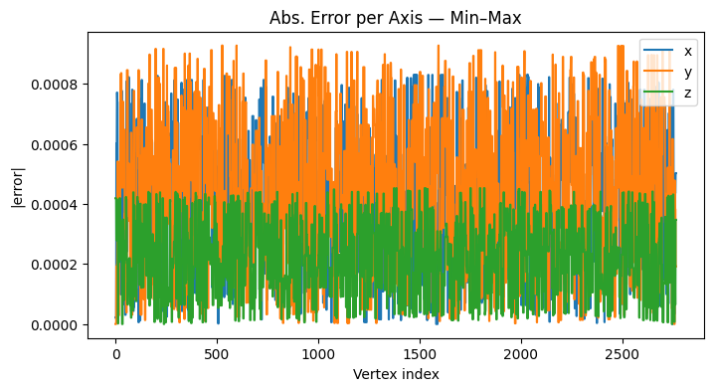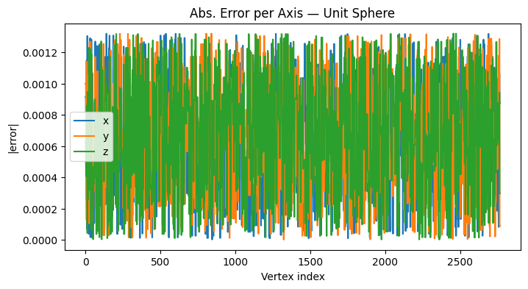

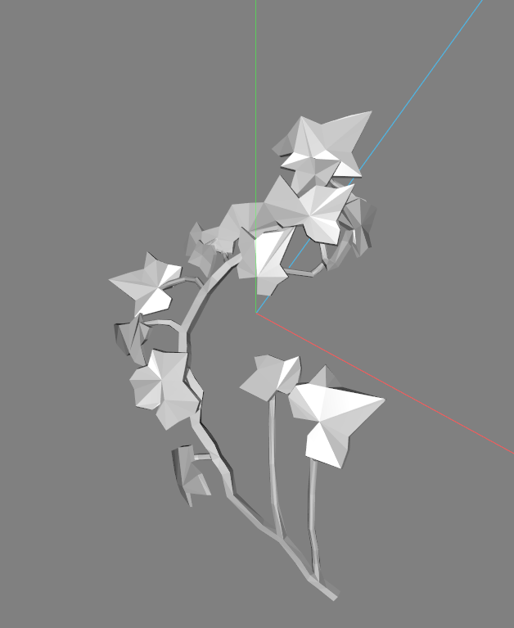
Quantized Unit
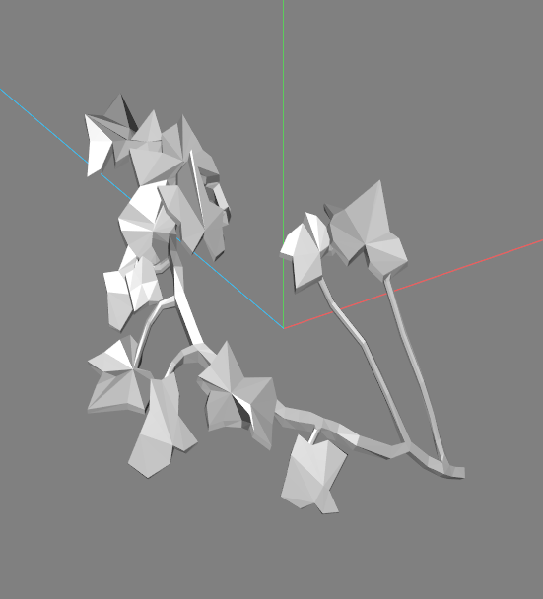

Quantized Minmax
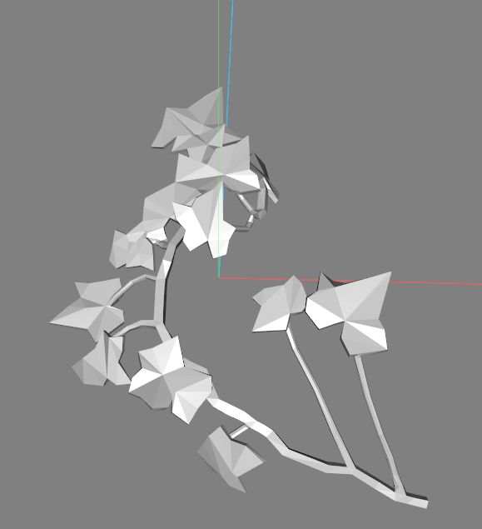

Normalized Unit
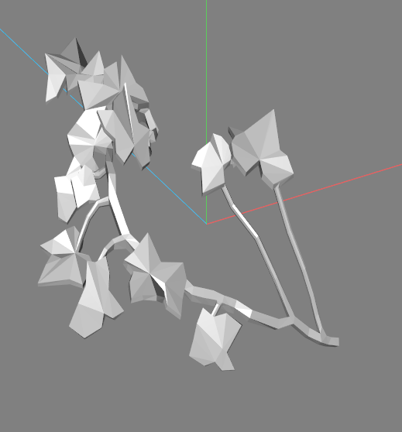
Normalized Minmax
Conclusion
Through this mesh normalization and quantization pipeline, it was observed that:
- Min–Max normalization tends to preserve detail for axis-aligned geometries but may introduce stretching or compression when one axis dominates in range.
- Unit Sphere normalization offers better structural preservation for symmetric or centered meshes, maintaining consistent scaling across axes.
- The average reconstruction error remained minimal across both methods, confirming the reliability of quantization and dequantization even with limited precision.
This project provided valuable insights into how geometric data can be numerically standardized and efficiently represented while minimizing information loss. It demonstrated how principles of normalization, quantization, and error analysis can together ensure high-fidelity 3D data reconstruction.

Thank you for giving me this opportunity
It’s been an absolute pleasure

